SR Wellness Report Tool

# Environment

**SR Wellness Report Tool** is developed in the specified environment. It is not fully tested. The only thing certain is that it would not work properly on Windows Server System.

The requirements described below based on the development and test by Jing Zeng (t-jizeng) in June, 2013.

## System Requirements

* Windows 7 (or higher) 32/64-bit
* Outlook 2013 (or higher)

## Development Requirements

* Visual Studio 2010 / .NET Framework 4 (click SR_Wellness_Report.csproj to open)
* Visual Studio 2012 / .NET Framework 4.5 (click SR_Wellness_Report.sln to open)

# Architecture

Registry

Export Form

Report Form

Email

Email

Email

Email

SSolve Report

.XML

# Implements

## Reference

* Microsoft.CSharp
* Microsoft.Office.Interop.Outlook
* System
* System.Core
* System.Data
* System.Data.DataSetExtensions
* System.Deployment
* System.Drawing
* System.Windows.Forms
* System.Xml
* System.Xml.Linq

## Class Diagram

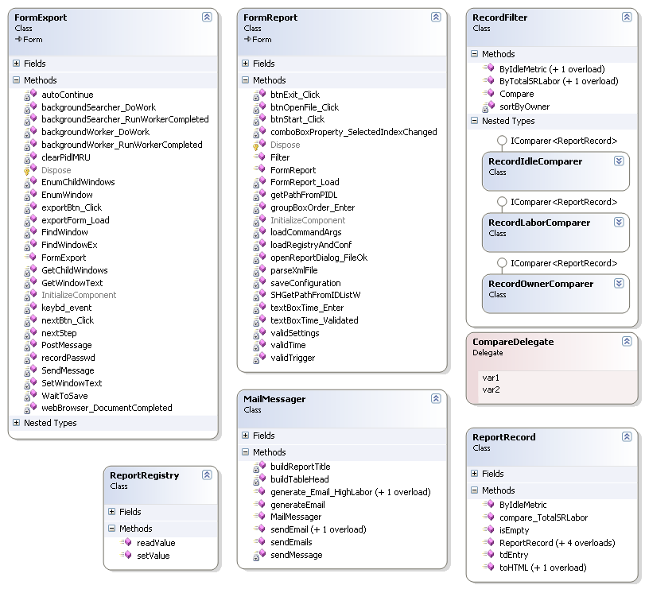

# Usage

**SR Wellness Report Tool** works either manually or automatically.

It must be run manually when it is the first time to run on your system. Necessary information will be captured so that it can be run automatically in the future.

Outlook must be opened when **SR Wellness Report Tool** is running.

## Manual Mode

**SR Wellness Report Tool** runs in user interface mode when it starts manually. Details are shown below.

### Double-click SR_Wellness_Report.exe

The address to retrieve report.xml is display in the combo box and selected by default. It is not supposed to change unless this address is no longer a valid one.

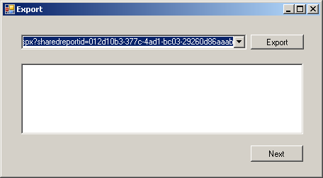

### Click Export button

**SR Wellness Report Tool** starts visiting that address. Input your password when Windows Security window is shown then click OK button. It takes about 12 seconds to generate a report.

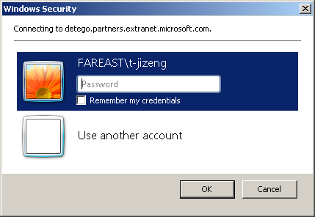

### Click Next button after Team Wellness Report is saved

Save the report wherever you want in the computer after File Download window is shown. After that, click Next button to go on. Actually, Next button can be used to go straight on to 4.1.4 after **SR Wellness Report Tool** starts.

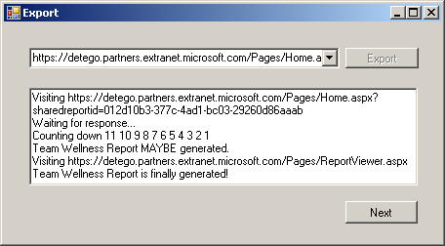

### Click Choose button

Find the report you saved in previous step by clicking Choose button or copy the full path to the text box directly.

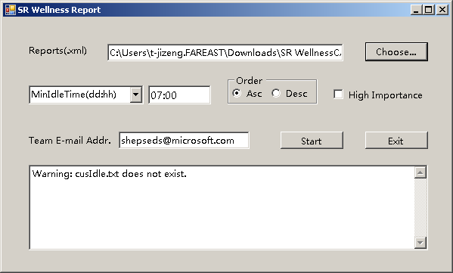

### Choose filter type

Choose the filter type in the combo box. The type of report sending to team members depends on the choice of filter type.

|  |  |  |
| --- | --- | --- |
| Filter type | Report type | Format |
| MinIdleTime(dd:hh) | Idle Case List | Days:Hours(07:00 by default) |
| MinTotalLabor(t1:t2) | High Labor Case List | t1:t2(400:800 by default, t1 < t2) |

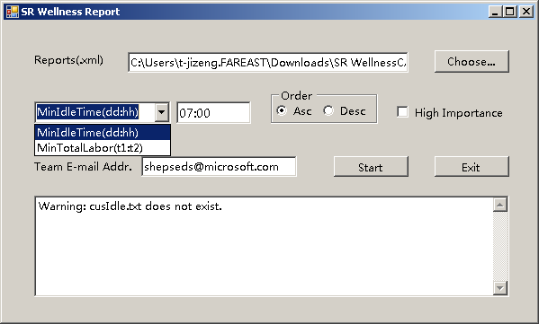

### Choose order and importance

The group box Order indicates how the case list is ordered by name of case owner, ascending or descending. The checkbox High Importance should be checked if the reports sending are considered important.

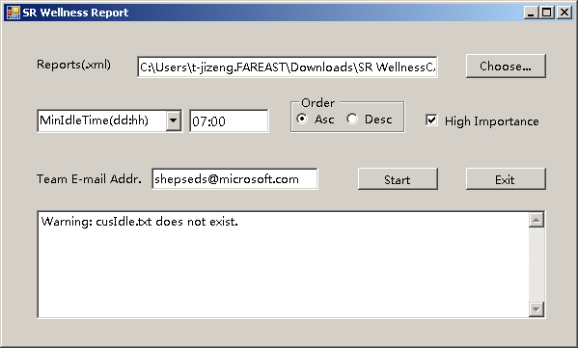

### Input team e-mail address

Important! Please make sure that you have input a valid e-mail address here. The program is not able to check the input a valid e-mail address or not right now.

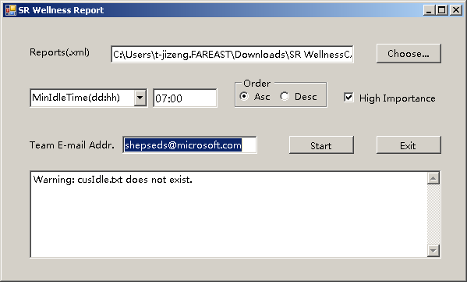

### Click Start button

Reports will be generated and sent to all the members included in SR Wellness Report after clicking Start button. Then click Exit button to finish.

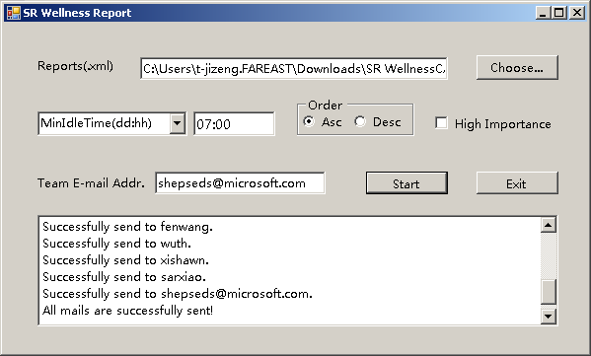

## Auto Mode

**SR Wellness Report Tool** works automatically by running it in a command window with supported options or configure in shortcut properties.

* --auto - run program in auto mode
* --debug - run program in debug mode
* --idle - send idle case list
* --tmpi - send high labor case list

## Configure Windows Task Scheduler

# Issues

Some bugs have already been found until now. These unresolved issues are listed below.

## Unable to Check Team E-Mail Address Valid or Not

## Idle Time Filter Configuration Has Not Been Tested

## Snipping Before File Download Window Shows Leads to Unpredictable Behavior

## Cannot Specify Recipient E-Mail Address in Debug Mode

## ~~Cannot Run Under Task Scheduler~~